Where We're At



Faster pace for remainder of course

– reverse instruction model (watch 1-2 assigned videos at home)
– reading textbook
– work solved problems, check answers in book (Appendix E-8)
– bring questions to class
– focus on using formulas correctly, not 'deep' understanding
– know how to parse a problem, choose correct formula, and solve
– video series links on class webpage (Khan Academy, jbstatistics)

1. Hypothesis Testing

Video khan: Hypothesis Testing and P-values (11:25)
https://www.youtube.com/watch?v=-FtlH4svqx4

Null and Alternative Hypotheses

Many applications of statistical inference in engineering involving testing some hypothesis, e.g., that a new product performs better than an old product, or that the number of defective units is less than some specified level.

However, classical statistical inference is somewhat backwards: we typically don't try to prove our hypothesis directly, but instead construct a second, 'opposite' hypothesis, and seek to reject that.

- Null Hypothesis: The opposite of our scientific hypothesis. Expressed in forms like "the new product performs the same as the old product." Because this hypothesis often implies no effect (e.g. old design and new design are equal), it is called the null hypothesis and is denoted as H₀.

- Alternative Hypothesis: Our actual scientific hypothesis (e.g., a new design is better than an old one) is called the alternative hypothesis. It is denoted as H₁.

In order to prove (or stated more accurately, to supply evidence for) our scientific hypothesis, we seek statistical evidence that will enable us to reject the null hypothesis as implausible.

This reverse-logic approach is the classical approach to statistical hypothesis testing. The modern (Bayesian) approach is more logical: it tries to directly test the original hypothesis; however we will not be considering the Bayesian approach here.

Errors in Hypothesis Testing

We can either reject or accept the null hypothesis; and it is either true or no true. This leads to four possible scenarios: two correct inferences and two incorrect ones.

 |  | True State
 |  | H₀ True  (No Effect) | H₀ False  (H₁ True)
Decision | Do not reject H₀ | Correct | Type II Error
Decision | Reject H₀ | Type I Error | Correct

The error probabilities are:

α = P(Type I error)
ß = P(Type II Error)

Test statistic. A sample statistic (e.g., sample mean) whose distribution is known if H₀ is true.

p-value. A measure of how likely or unlikely the observed test statistic value is under the assumption that the null hypothesis is true.

A low p-value indicates that the test statistic value is unlikely given the null hypothesis; we therefore reject the null hypothesis as unlikely. This is evidence that our scientific hypothesis, H₁, is true.

If the p-value is not sufficiently small then we do not have evidence that H₀ is false and we do not reject the null hypothesis.

The p-value and α are related, but are different concepts. As we shall see, we fix α in advance, but the value of p depends on the result of our study.

The term statistical significance is used somewhat inconsistently to refer either to α or to the p-value.

2. The p-Value Approach to Hypothesis Testing

There are two different conventions for statistical hypothesis testing under the classical paradigm:

- the p-value method
- the critical value method

The p-value and critical value methods produce the same results. We will use the p-value method in this class.

The p-value is the probability of obtaining a test statistic value equal to or more extreme than that actually observed given that that the null hypothesis H₀ is true.

Performing Statistical Inference Using the p-value Method

It is assumed that you wish to test a hypothesis about some population parameter (e.g., the population mean, μ). For this, you collect and analyze data taken from a sample of size n.

Steps:

- State the null hypothesis, H₀ – for example, that the population mean, μ, is equal to some constant, c.

- State the alternative hypothesis, H₁. For example, that the same population mean is not equal to (≠), greater than (>), or less than (<) the same constant (c) used in H₀.

- Choose the level of statistical significance, α. This stipulates the acceptable risk of a Type 1 error (rejecting H₀ when H₀ is true). Typical values for α are 0.05 and 0.01. If a Type 1 error is especially dangerous (e.g., releasing an ineffective medicine), one may choose a smaller α, such as 0.001.

- Choose which test statistic to use. For a hypothesis concerning a single population mean, we use one of the following:

Z test Statistic for μ (σ Known) | t test Statistic for μ (σ Unknown)
 | $$t=\frac{\bar{X}−μ}{\frac{s}{\sqrt{n}}}$$

where s above is the sample standard deviation.

- Compute the value of the appropriate test statistic. Example:

H₀: μ = 10.
H₁: μ ≠ 10.

Sample mean = 12, n = 100, s = 8

Test statistic = t = (Sample mean – μ) / [s / √n]

- Calculate the p-value of the test statistic. For a test of a mean, this is the area in the tail(s) of a standard normal distribution (z) or t distribution (t) corresponding to the calculated value of your test statistic.

- Compare this p-value to your original α.

- If p < α, reject H₀. Conclude that H₁ is plausible.
- If p ≥ α do not reject H₀. You do not conclude that H₁ is plausible.

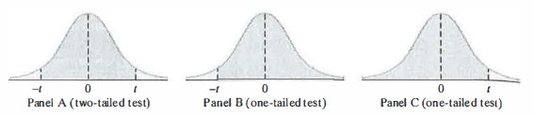

One and Two-Tailed Significance Tests

Sometimes we want to know if a population parameter is greater (or less) than some expected value; then we perform a one-tailed significance test. Other times we only want to know if a population parameter is different from some expected value; then we perform a two-tailed significance test.

A two-tailed test rejects the null hypothesis if the sample estimate (e.g., sample mean) is significantly different than the hypothesized value of the population parameter.

H₀: Parameter = hypothesized value (e.g., μ = 27)
H₁: Parameter ≠ hypothesized value (e.g., μ ≠ 27)

A one-tailed stipulates in H₁ whether you predict the sample estimate to be higher or else lower than the hypothesized value of the population parameter.

H₀: Parameter = hypothesized value (e.g., μ = 27)
H₁: Parameter < hypothesized value (e.g., μ < 27; left-tailed test)
or
H₁: Parameter > hypothesized value (e.g., μ > 27; right-tailed test )

3. The t-statistic

- If we don't know the population standard deviation and must estimate it from a sample, we use the t statistic instead of the z statistic.

- The t statistic has a distribution like the normal distribution, but with fatter tails.

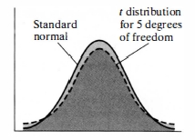

- The t distribution differs slightly according to sample size. When you use it, you must also specify the number of degrees of freedom (df).

- Degrees of freedom = n – 1 (where n is the sample size).

- There is an Excel function, tdist() to compute areas of the t-distribution but we will not use it.

4. Testing One Sample Mean Using JMP

Follow same steps as with estimating a credible/confidence interval.
1. Start JMP
2. Make new Data Table
3. Paste/type data into Column
4. Highlight Column
5. Analyze > Distribution

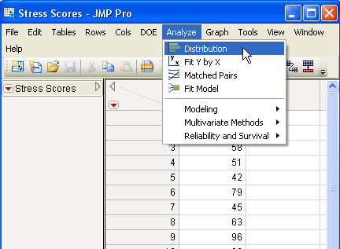
Step 5

6. In pop-up window designate your variable as Y, Columns and press OK
7. Click red arrow in histogram (Distributions) area
8. Select Test Mean in drop-down menu

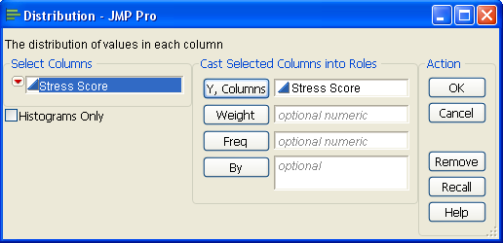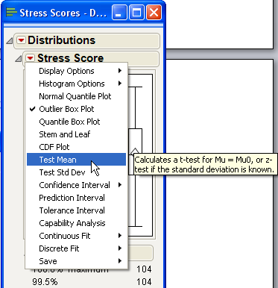

Steps 6 (Left) and 8 (Right)

9. Type in mean (for H₀)
10. Type in population standard deviation (if known)
11. Press OK

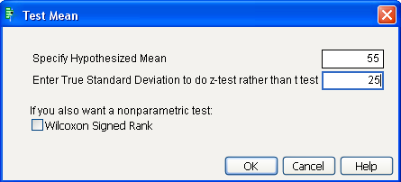

Steps 9 and 10

12. Results will appear in report in new section titled Test Mean. For more detail, click red arrow and choose PValue Animation.

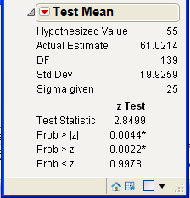
Step 12

5. Homework

Homework:
Review pp. 392–398 (Skip “Critical Value” and “Regions” sections)
Review pp. 398–410
Read: pp. 413–418, 427–431

Work Problem 9.7(a):

A machine being used for packaging seedless golden raisins has been set so that, on average, 15 ounces of raisins will be packaged per box. The quality-control engineer wishes to test the machine setting and selects a sample of 30 consecutive raisin packages filled during the production process. Their weights are found in the spreadsheet raisins.xls (class website).

(a) Is there evidence that the mean weight per box is different from 15 ounces? (Use a = 0.05.)

- Set up formulas, compute t-statistic (t-test of one mean, σ unknown).
- Then analyze using JMP (t-test of one mean, σ unknown)
- Answers are in back of book (Appendix E-8)
- Bring to class

Watch Khan Academy video: Confidence Interval 1
https://www.youtube.com/watch?v=bekNKJoxYbQ

